***Movie Recommender System Application***

Recommendation engine is a very popular area of interest on how does the content which we love is delivered to us, so this project explains about the tools and techniques used by the industries which helps them top recommend the stuff which we love to increase their viewership. The main objective of the project is to recommend the movies for the user, the tools which we have used in here are Sklearn, NLTK (natural language tool kit) and pandas’ functionality to manipulate and extract information from the dataset, finally we have used stream lit as a web framework to integrate the code with a small stream lit application, which allows you to get your hands on an actual website where you get the recommendation for your desired movies.

***Base Paper***

1. <https://www.researchgate.net/publication/283042228_A_Movie_Recommender_System_MOVREC>
2. <https://www.ijcaonline.org/research/volume124/number3/kumar-2015-ijca-904111.pdf>

***Project Methodology***

***Count Vectorizer:*** They are used for converting a collection of term document to a vector. It also helps the pre-processing of text data prior to generate the representation of vector. They are transformed according to the frequency which comes in the entire text. They create a matrix in which columns are represented as words and rows are represented as text sample.

**References:**

1. <https://www.geeksforgeeks.org/using-countvectorizer-to-extracting-features-from-text>

***Stream lit:*** Stream lit is a small and easy web framework which helps us to build beautiful websites. The main reason for using stream lit is that it offers very user-friendly experience and we don’t need to have a prior knowledge of HTML, CSS and JAVASCRIPT. Streamlit is mostly used for deploying machine learning models without using any external cloud integrations. Some of the applications of Streamlit are it helps to deploy Machine learning and deep learning models, it can also help us to build a front end for a normal code. The output can be viewed as local server in your web browser.

**References:**

1. <https://www.geeksforgeeks.org/streamlit-introduction-and-setup>

***Steps to Execute the Code!***

**Note:** Make sure you have added path while installing the software’s.

<https://techieyantechnologies.com/2022/07/how-to-install-anaconda/>

<https://techieyantechnologies.com/2022/06/get-started-with-creating-new-environment-in-anaconda-configuring-jupyter-notebook-and-installing-libraries-using-requirements-txt-2/>

1. Install the prerequisites/software’s required to execute the code from reading the above blog which is provided in the link above.
2. Press windows key and type in anaconda prompt a terminal opens up.
3. Go to the directory where your requirement.txt file is present, not just requirement.txt, if you want to execute any .py or .ipynb files, you need to go to that specific folder or path, where they are saved.

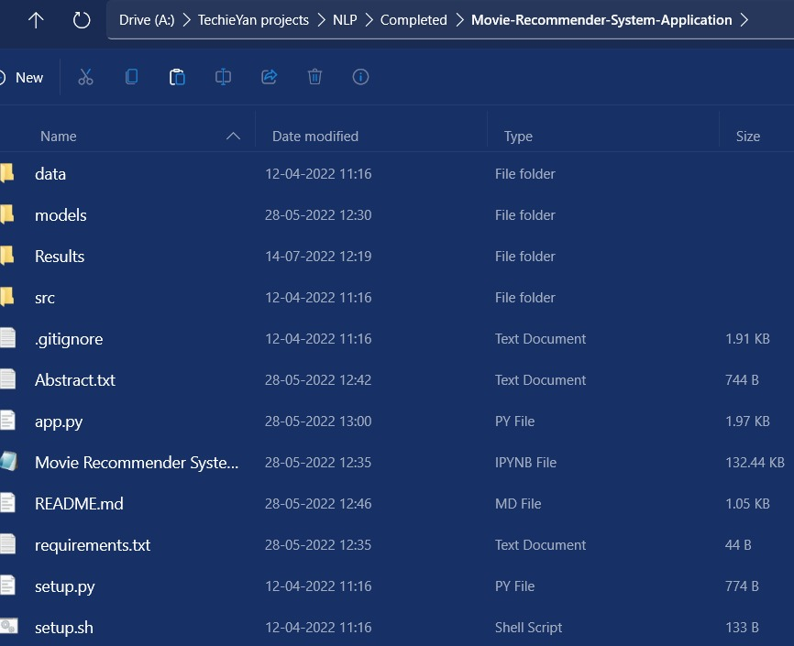

1. <<directory of your file:>>. E.g., If my file is in d drive, then
2. Type d:

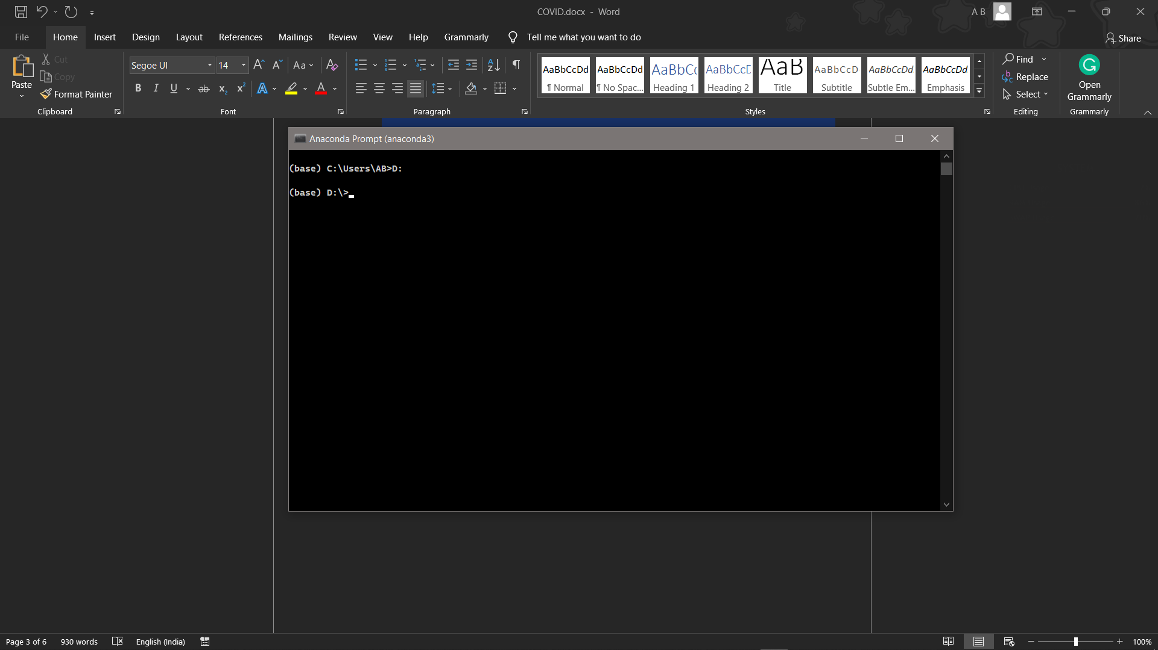

1. cd d:\License-Plate-Recognition-main #CHANGE PATH AS PER YOUR PROJECT, THIS IS JUST AN EXAMPLE

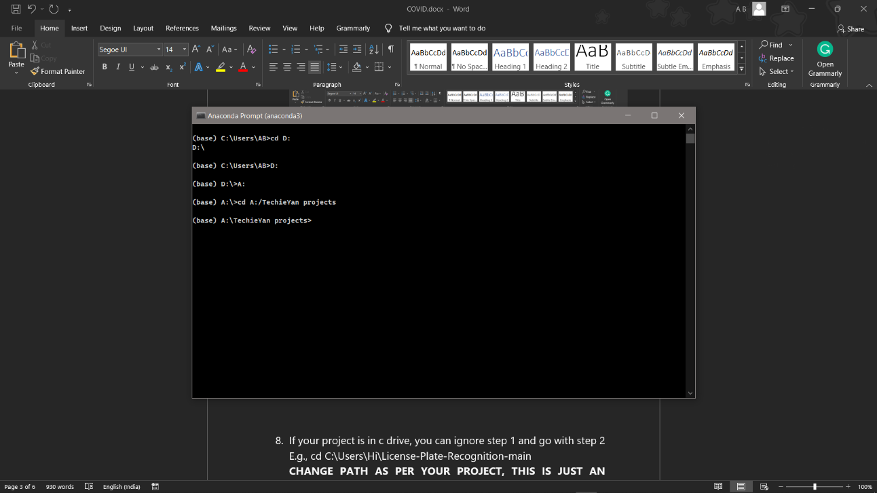

1. If your project is in c drive, you can ignore step 4 and go with step 5.

E.g., cd C:\Users\Hi\License-Plate-Recognition-main

**CHANGE PATH AS PER YOUR PROJECT, THIS IS JUST AN EXAMPLE**

1. Run pip install -r requirements.txt or conda install requirements.txt (Requirements.txt is a text file consisting of all the necessary libraries required for executing this python file. If it gives any error while installing libraries, you might need to install them individually.), example: pip install “module_name” i.e., pip install pandas

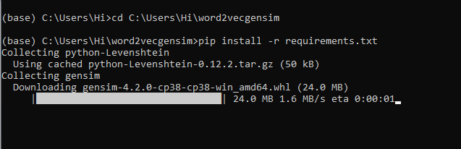

1. If you would like to run **app.py** file, please [follow the given link on how to setup anaconda prompt](https://techieyantechnologies.com/2022/07/how-to-install-anaconda/), and make sure to change the path where your executable file/folder is saved i.e., follow 5,6,7 steps and type **streamlit run app.py**

***Dataset Description***

The dataset was downloaded from a kaggle data repository. The dataset has been pre-processed and cleaned to remove any bias while training.

Basically, it has 4800 rows and 20 columns in the dataset. The dataset contains all the information about the movie and the details of the crew members who were involved in making these movies. The columns represent the details about the movie such as title , crew, movie_id and the casting members. The rows briefly explain about those details in it.

**Ex:** Movie Name: Avatar, The character was of Jake Sully with no gender in it and it got a popularity of more than 150.4376

**IMBD Movie Dataset**

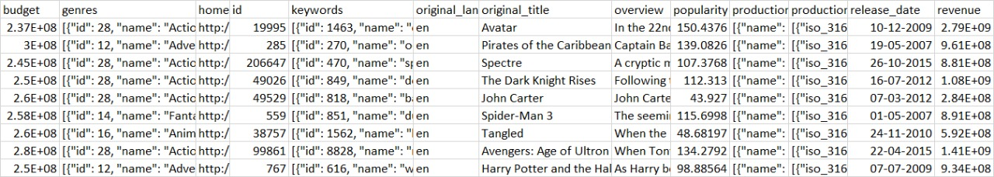

**IMBD 5000 Credits Dataset**

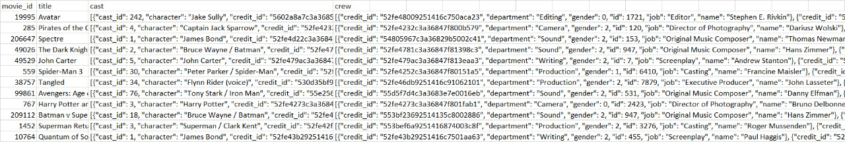

***Issues Faced***

1. We might face an issue while installing specific libraries, in this case, you might need to install the libraires manually. Example: pip install “module_name/library” i.e., pip install pandas

2. Make sure you have the latest or specific version of python, since sometimes it might cause version mismatch.

3. Adding path to environment variables in order to run python files and anaconda environment in code editor, specifically in any code editor.

4. Make sure to change the **paths in the code** accordingly where your dataset/model is saved.

**Refer to the Below links to get more details on installing python and anaconda and how to configure it.**

<https://techieyantechnologies.com/2022/07/how-to-install-anaconda/>

<https://techieyantechnologies.com/2022/06/get-started-with-creating-new-environment-in-anaconda-configuring-jupyter-notebook-and-installing-libraries-using-requirements-txt-2/>

***Note:***

**All the required data has been provided over here. Please feel free to contact me for model weights and if you face any issues.**

<https://www.linkedin.com/in/abhinay-lingala-5a3ab7205/>

***Yes, you now have more knowledge than yesterday, Keep Going.***

***Result:***

1. **Movie Recommendation system:**